DT021-3 Thyristors and Thyristor Controlled Rectifiers

- The Thyristor also known as a Silicon Controlled Rectifer (SCR)

Construction: 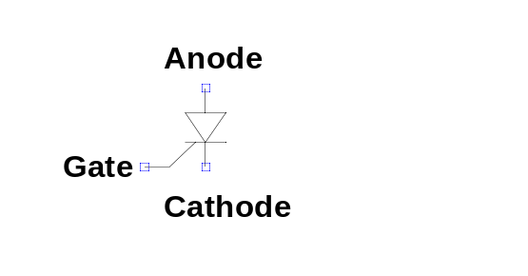
K
P
N
P
N
A
G
Two Transistor Equivalent Model:

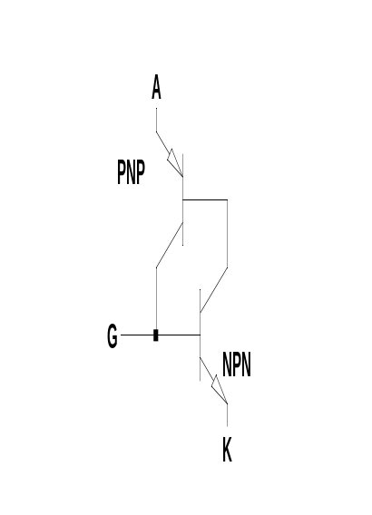
P
N
P
N
A
K
N
P
G

Explanation of Two Transistor Model:
If the pnp transistor is initially off and no current is provided at the gate then the pnp transistor has no base current and is off. This in turn means that the PNP transistor had no base current and also remains off. The thryistor remains in its non conducting state.

On the other hand if we introduce a small current into the gate this will turn on the NPN transistor. Providing there is external voltage applied between Anode and Cathode then current flow into the base of the PNP and through the npn. This will turn on the pnp which in turn will supply base current to the NPN even after the external base current has been removed. The thyristor latches on It will remain on until the external voltage is removed at which time it will revert to its non-conducting state.

In practise once the gate current is removed the device will only remain on providing the the anode current has exceeded a certain minimum value known as the Latching current. Once the latching current has been achieved the device will remain on until the anode current falls below a lower current level called the holding current.
Note that I_{L}>I_{H}

Note: Latching current and holding current scale with current rating of the thyristor so it is important to correctly size a thyristor for an application. If you use a thyristor with too generous a current rating the circuit current may not build up to the latching current during the gate pulse and the thyristor may not latch on.

Note that once a standard thyristor has started conducting it cannot be turned off via the gate. It behaves like a diode until such time as the anode current falls below the holding current and the device reverts to its blocking state.

Applications of Thyristors
Thyristors are extremely robust semi-conductors and a wide range of models are available up to very high levels of voltage and current. Thyristor converters have been implemented at power levels of up to 100’s MW for example in the DC link between the power grids of Ireland and Scotland. A version of the thyristor called a TRIAC is also widely used in low cost low power AC control systems (for example in dimmer switches for incandescent light bulbs.

Thyristor Derivatives:

Triac: Effectively two back to back thyristors in one package with a single gate. Widely used for AC power control.
GTO: A thyristor which can be forced to turn off by pulling current out of the gate.
IGCT: Based on an GTO with integrated gate drive circuit. Optimised for fast turn on and off.
MCT: A hybrid of Mosfet and Thyristor. The thyristor may be turned on or off by application of a appropriate voltage signal to the gate. Allows high speed switching.

Half Controlled Single Phase Bridge Rectifier (Semiconverter)

Circuit Diagram:

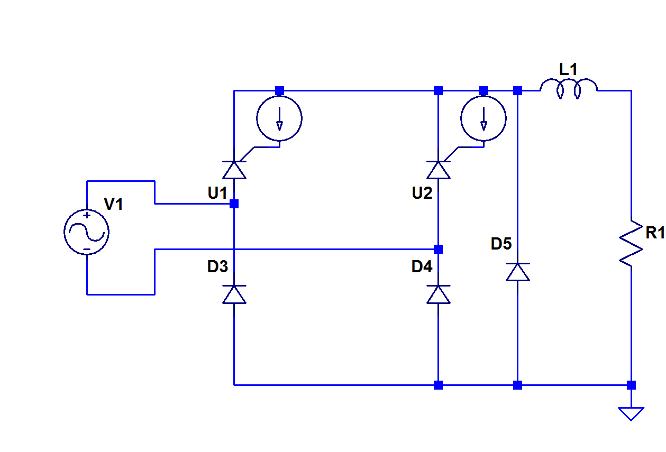
Description: A full wave bridge rectifier in which the top two diodes are replaced by thyristors. The turn on of each thyristor is delayed by a time α (radians) from the time that a diode in that position would naturally conduct. By delaying conduction in this way the average output voltage may be controlled. An inductor is included to smooth the output ripple. We assume that the corner frequency of the filter provided by L and R is much lower than the frequency of ripple (2xf_{ac}) so that the ripple is greatly attenuated and the output current in R is almost pure DC. For good filtering: 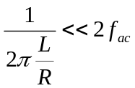

During the delay time (α) the inductor current requires a freewheel path and this is provided by D5. In fact the circuit can work without a freewheel diode because the current can also freewheel through a leg diode and associated thyristor (for example D3 and U1). However a separate freewheel diode reduces losses because the voltage drop across the freewheel path is lower.

Voltage Waveforms
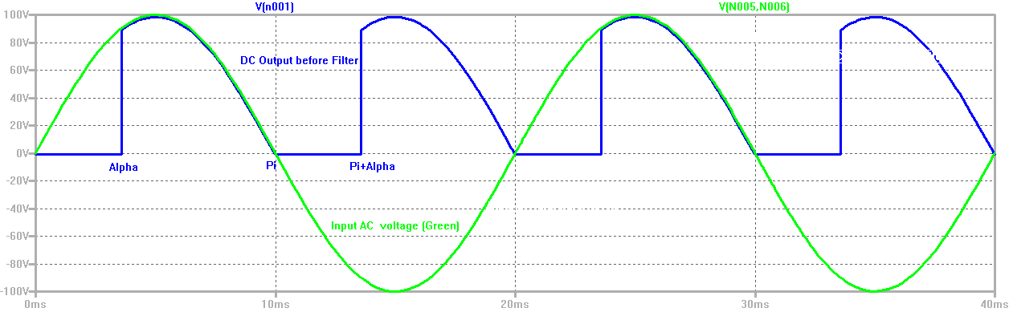
The plot above shows the Input Voltage sinewave (Green) and the unfiltered DC output measured across D5 (Blue). The firing angle Alpha in this case is 63.5°. The plot below shows the effec tof the LR filter. The red line is the filtered output voltage which is a smooth DC voltage equal to the average of the voltage across D5.

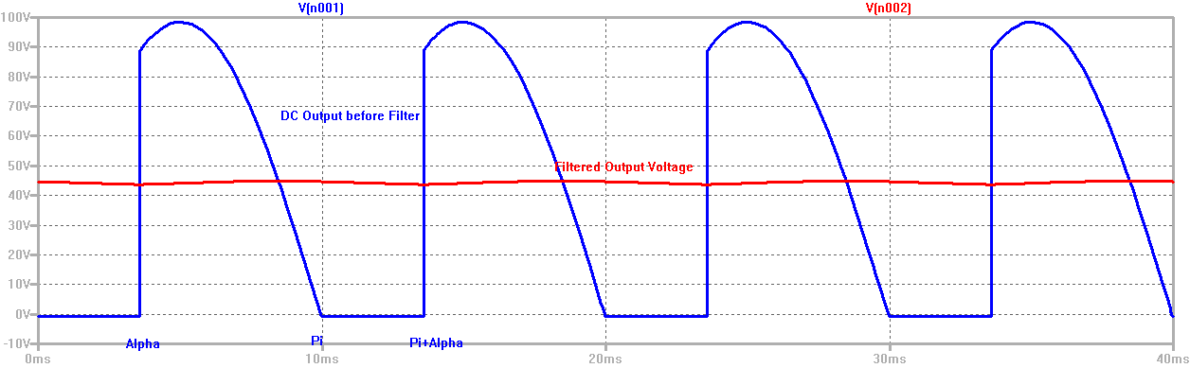

If the firing angle (α) is zero then the output is identical to a diode bridge rectifier. As the firing angle is increased the proportion of the rectified wave that is let through diminishes and the average output voltage falls.

Notice that the region for which alpha makes sense is: 0 ≤ α ≤ π radians.
Current Waveforms
Outpur Current (R1)
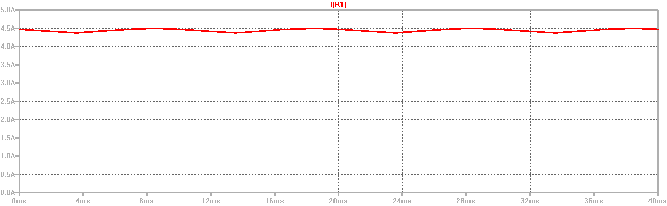
U1 anode current and U2 Anode Current
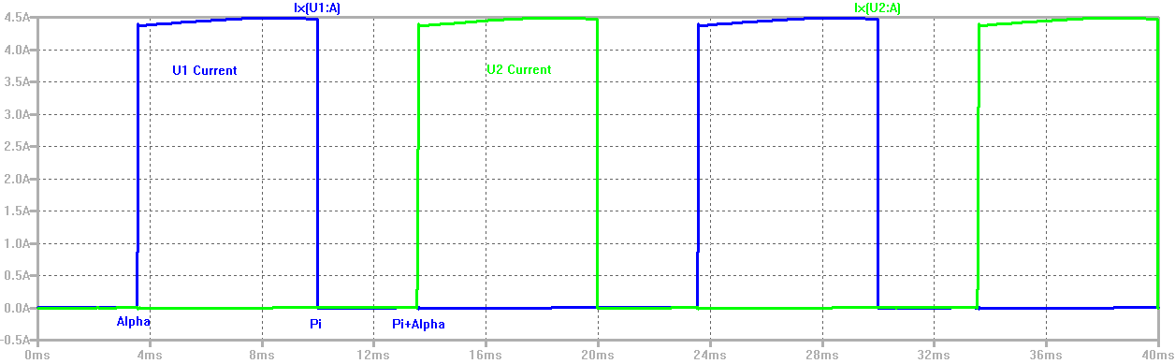
D3 and D4 current
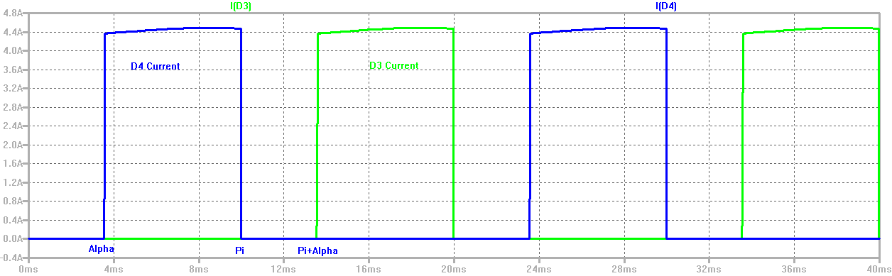
Where does inductor current flow during the gaps (dead time)?
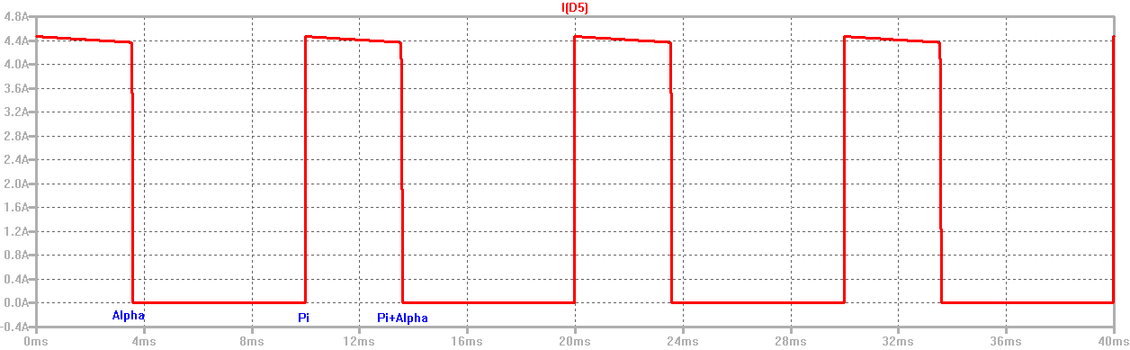
Notice that the output current is quite smooth with low ripple. During the positive half cycle the output current flows through U1 and D4. During the negative half cycle it flows through U2 and D3. During the dead times (between 0 and α and between π and π+α the inductor causes the current to freewheels through D5).

AC Line Current
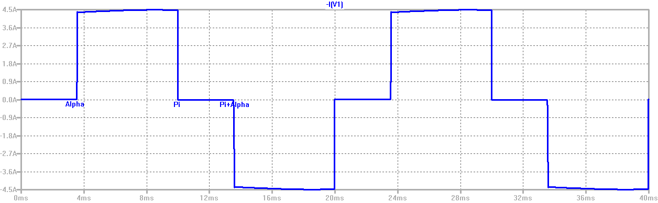

From Kirchoff’s first law we can see that the AC input current equals U1 current minus D3 current. This is a square wave with dead time in the regions 0 to α and π to π+α.

Analysis
Average output Voltage:
The output voltage V_{o} can be obtained by calculating the average of the voltage across D5:
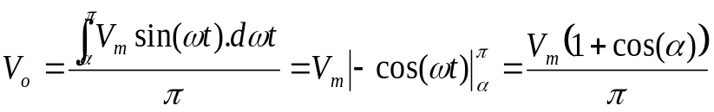
Where
V_{o}=Average DC output voltage
V_{m}=Peak of AC input sinewave voltage
α=firing angle (0< π radians)

Notice that at α=0 the output voltage is 2V_{m}/ π which is just the average value of a full wave rectified sinewave and is the same output voltage eyou would get from a four diode bridge rectifier with LR filter.
As α increases the voltage falls off along a cosine curve falling to zero at α= π.
Values of α greater than π radians do not make sense because the thyristors are reversed biased after π radians and will not conduct even if they get a gate pulse.

RMS Input Current:
It will be useful also to calculate the rms value of the ac input current. Since the positive and negative half cycles are mirror images of one another we need only calculate the rms over π radians. Neglecting the small ripple on the output current:

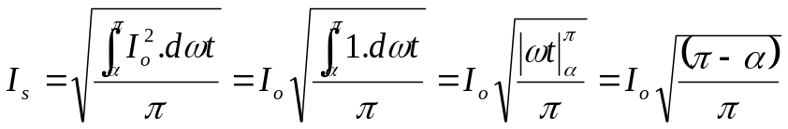

Remember of course that 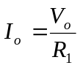
Where
I_{s}= rms input ac current
I_{o}=average dc output current

Rectification Ratio (rectification efficency)
With an appropriately sized inductor the output ripple can be reduced to a negligible value giving a rectification ratio as close to 100% as required.

Utilisation Factor:
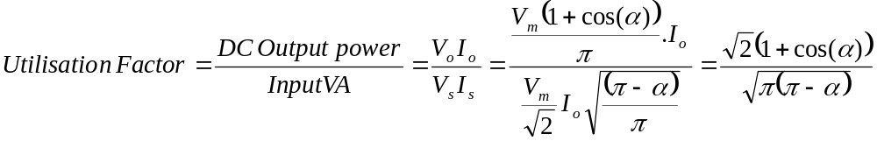

AC Power Factor

For a single phase system with non sinusoidal input currents the input power factor is defined as: 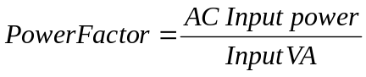

From energy balance we can say that AC Input power = DC output Power + AC Output Power + Losses

So if we assume that the L/R time constant is large enough to filter out any output voltage ripple and also that losses in the Thyristors and diodes are negligible (assume that the forward voltage drop is a small fraction of the output voltage) then we can approximate:

AC input power = DC Output Power

In which case the Power Factor = Utilisation Factor = 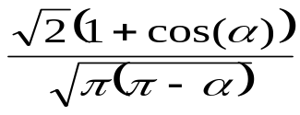

Notice that when α=0 Power Factor =0.9
When α=π/2 Power Factor = 0.637
As α approaches π the power factor falls to 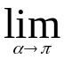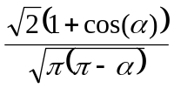=0

Comment on power Factor
Most utilities impose a sever penalty on commercial customer who have a poor power factor. In Ireland penalties are imposed for power factors below 0.95. A major disadvantage of the thyristor controlled rectifier is that its power factor becomes very poor at low output voltages.
Why does the power factor degrade?

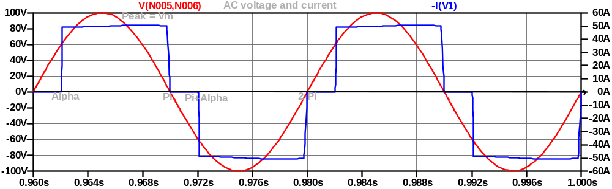

- Phase shift – By observation of the current waveform we can see that the fundamental of the current waveform is phase shifted by an angle α/2 .This phase shift contributes to the reduction in power factor
- In systems with non sinusoidal currents the harmonics also contribute to the reduction in power factor.

More Complete Definition of power Factor

Previously you learned that power factor = cos(φ)

A more complete definition of power factor is

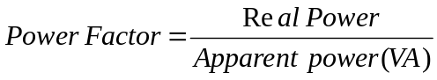
In a system with sinusoidal voltage and current this become the familiar form
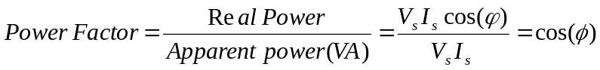

If the current waveform is no sinusoidal however and has harmonics it turns out that only the fundamental component of the current (I₁) gives real power. The harmonics just contribute to poor power factor.
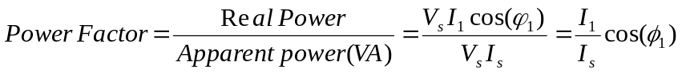

Exercise:
A half controlled thyristor rectifier with LR filter is required to supply a 150V / 10Amp resistor load. The AC input voltage is 230V rms at 50Hz. Losses in the rectifier may be assumed to be negligible.
1. Sketch the circuit diagram of the rectifier required.
2. Recommend a value of inductance such that the filter cut off frequency is 5% of the output’s ripple frequency. (Answer 477mH)
3. Calculate the firing angle (α) required. (63° / 1.1 radians)
4. Sketch the voltage waveform across the freewheel diode.
5. Sketch the input current waveform.
6. Calculate the rms input current. (8.05A)
7. Calculate the power factor of this rectifier. (0.81)
8. Calculate the fundamental component of the ac supply current. (7.6A)

More Jargon:
Some further terms you may come across in relation to thyristors and rectifiers:
Phase Control: Thyristor circuits where the thyristor firing angle is determined by the phase of the ac supply.
Line Commutated: Thyristor circuits where the thyristors are left to conduct until the natural part of the cycle where a diode in the same position would turn off.
Force Commutated: Thyristor circuits where some means is used to turn of fthe thyristor at a point other than the natural part of the cycle.

